Project Design Phase
Solution Architecture

Date | 1 July 2026
Team ID
Project Name | Online Complaint Registration
Maximum Marks | 4 Marks

Solution Architecture:
The Online Complaint Registration System provides a centralized platform for users to register complaints, track complaint status, and receive updates. The solution bridges the gap between citizens and administrators through a secure web-based system built using the MERN Stack. Its goals are to:
- Provide an easy and efficient method for registering complaints online.
- Enable users to track complaint status in real time.
- Allow administrators to manage, assign, and resolve complaints efficiently.
- Improve transparency and communication between users and departments.
- Ensure secure access through authentication and authorization mechanisms.
- Support future scalability with cloud deployment and notification services.

Online Complaint Registration System – Solution Architecture Diagram:

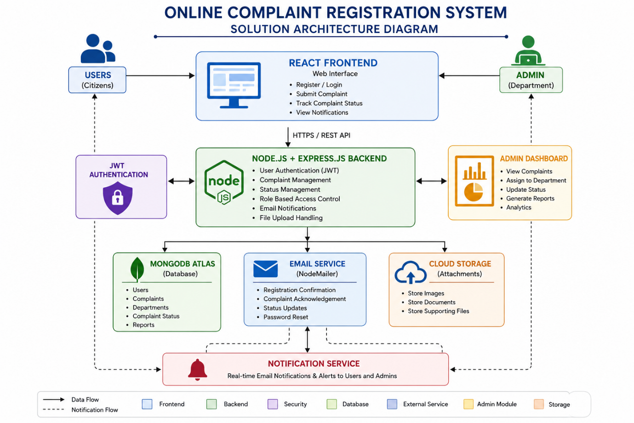
Figure 1: Architecture and data flow of the Online Complaint Registration System.
Reference: https://www.mongodb.com/resources/languages/mern-stack/

